Monthly Report on Cybersecurity Trend Analysis
Task Number: task2000-2026-05
Reporting Period: May 2026

Executive Summary
This month, the cybersecurity situation has shown three core changes. Management and the technical team need to pay close attention to the following:
Exploit utilization has surpassed credential theft and has become the most significant vector for intrusion: According to Verizon's 2026 DBIR, 31% of data breaches began with exploit utilization. The explosion of AI-assisted attacks has compressed the window from which vulnerabilities are "public" to "being exploited in the wild" from several months to just a few hours.
High-risk privilege escalation vulnerability CVE-2026-31431 ("Copy Fail") in the Linux kernel has emerged: This vulnerability affects all major Linux distributions since 2017. Low-privileged users can bypass the kernel protection and seize root privileges by exploiting a specific buffer overflow script of only 732 bytes, posing a devastating threat to cloud-native environments and Kubernetes clusters.
Leakages related to third-party supply chains have increased by 60% year-on-year, accounting for 48% of the leaks this month. Instructure/Canvas was attacked by the top hacking group ShinyHunters, resulting in the leakage of approximately 275 million educational and student data, exposing the deep vulnerabilities of federated identity and uncontrolled third-party API permissions.

I. Threat Overview
1.1 Major Vulnerabilities This Month

CVE number | name | CVSS | influnce | state
CVE-2026-31431 | Copy Fail | 7.8（high） | All major Linux distributions (kernel 4.14 and above, since 2017) | The PoC has been made public and the patches are being released one after another.
— | OpenAI GitHub Actions configuration error | — | Code signing certificate infrastructure | It has been disclosed that no user data has been confirmed to have been leaked.

CVE-2026-31431 Details: This vulnerability is located in the Linux kernel encryption subsystem algif_aead module, belonging to a pure logical error, no race conditions are required, the exploitation reliability is close to 100%. Attackers can achieve privilege escalation by modifying system tools in memory (such as /usr/bin/su) or configuration files (such as /etc/passwd), and the disk files remain unchanged, the traces disappear after a restart, posing a great challenge to integrity detection. In container environments, this vulnerability can further trigger container escape.

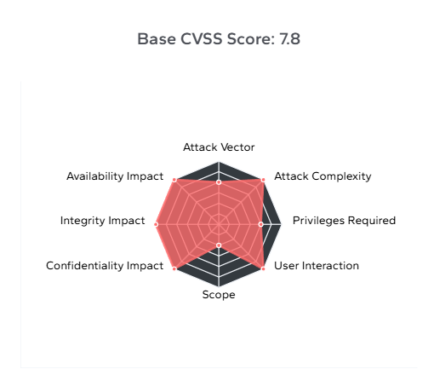
Temporary Mitigation Measures: bash
echo "install algif_aead /bin/false" > /etc/modprobe.d/disable-algif.confrmmod algif_aead 2>/dev/null || true
1.2 Major Security Incidents This Month
Instructure/Canvas Large-scale Data Breach The ShinyHunters ransomware organization breached the cloud-hosted environment of the world's largest LMS (Learning Management System) Canvas, claiming to have stolen approximately 275 million student, teacher, and employee records, affecting 8,809 schools, universities, and online education platforms.
Two Major U.S. Banks Invaded Through Third-Party Suppliers The Everest ransomware organization listed two major U.S. banks simultaneously on a dark web leak site in late April. The invasion vector was a shared third-party supplier, once again confirming the high-risk nature of supply chains as attack vectors.
JRK Property Holdings Ransom Attack The real estate investment company JRK Property Holdings was attacked by The Gentlemen organization, resulting in the leakage of the personal information of approximately 111,000 people (including names and social security numbers), which has triggered a class-action lawsuit.
Brightspeed Telecom User Data Breach The new cyber ransomware organization Crimson Collective claimed to have stolen over 1 million Brightspeed telecom user data.

II. Trend Analysis
2.1 AI-Driven Attacks: From Tools to Infrastructure
The most notable industry trend this month is that AI has evolved from an "auxiliary tool" to an attack on infrastructure.
Verizon's 2026 DBIR clearly states that AI is reshaping the threat landscape by accelerating the exploitation of known vulnerabilities, compressing defenders' response windows from months to hours. What is even more alarming is that there are empirical cases of fully automated AI attack components in this reporting period:
•PromptLock: The first AI-driven ransomware that dynamically generates cross-platform encryption scripts using local LLM
• VoidLink: A malicious framework autonomously constructed by an AI agent in six days
IBM X-Force indicates that the greatest risk is not the attack on the AI platform itself, but the significant increase in the scale and accuracy of credential harvesting due to AI-assisted phishing attacks and information theft software. North America has surpassed Asia-Pacific for the first time and become the region most attacked globally, accounting for 29% of X-Force incident response cases.

2.2 Variants of Remcos RAT and Its Concealed Anti-Detection Techniques
The activity of the Remcos RAT variant in commercial remote control malware has significantly increased this month. Its delivery vector mainly relies on "AI-assisted customized phishing emails".
Concealed Execution Chain (Living-off-the-Land): The attackers abandoned the traditional binary .exe landing method and instead used Adobe PDF files containing malicious macros or OLE objects to guide the attack. Their anti-detection and maintenance methods are highly technical:
1. White-Listing (LOLBins): After triggering, it uses the system's built-in certutil.exe to download the encrypted Payload and calls regasm.exe to inject and execute.
2. API Hook Avoidance (Unhooking): This Remcos variant has advanced Syscalls (direct system calls) bypassing technology. It directly reads the clean copy of ntdll.dll in memory and restores the user-mode hooks (Hooks) injected by EDR (such as Windows Defender, CrowdStrike), causing EDR to be completely "blind" and unable to monitor its sensitive memory reads and process injection operations.
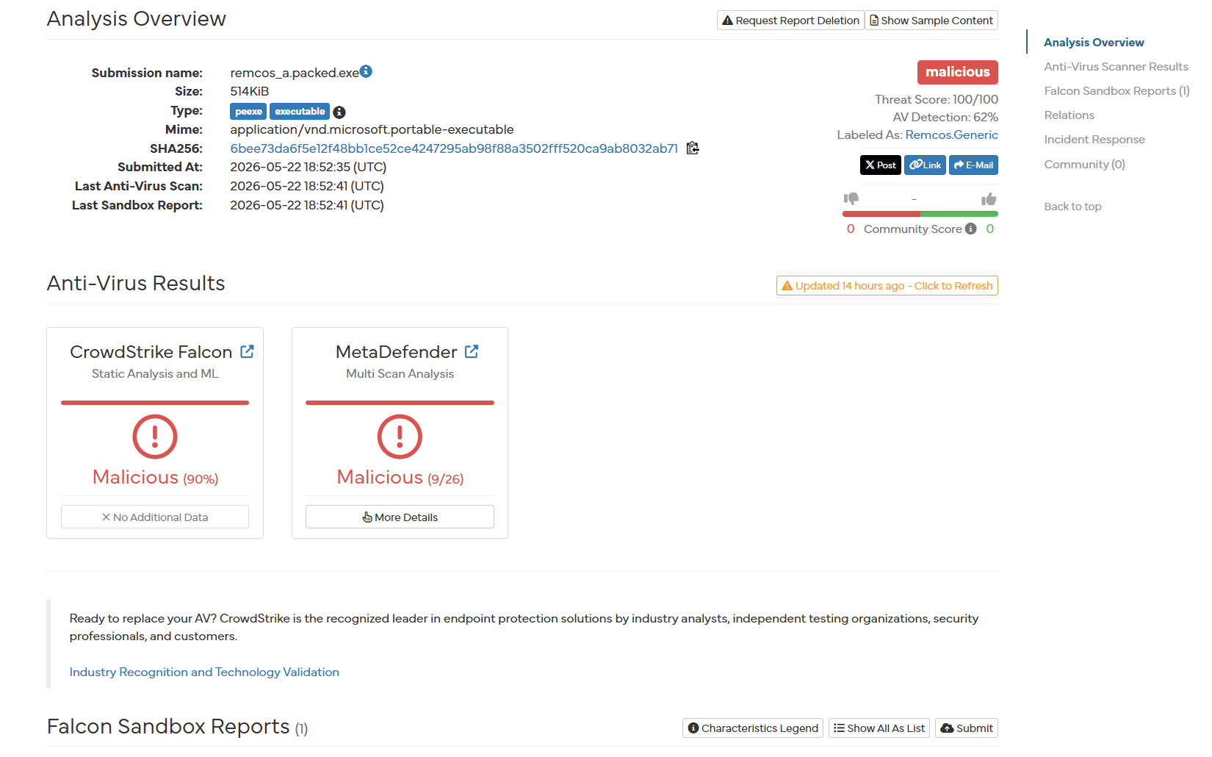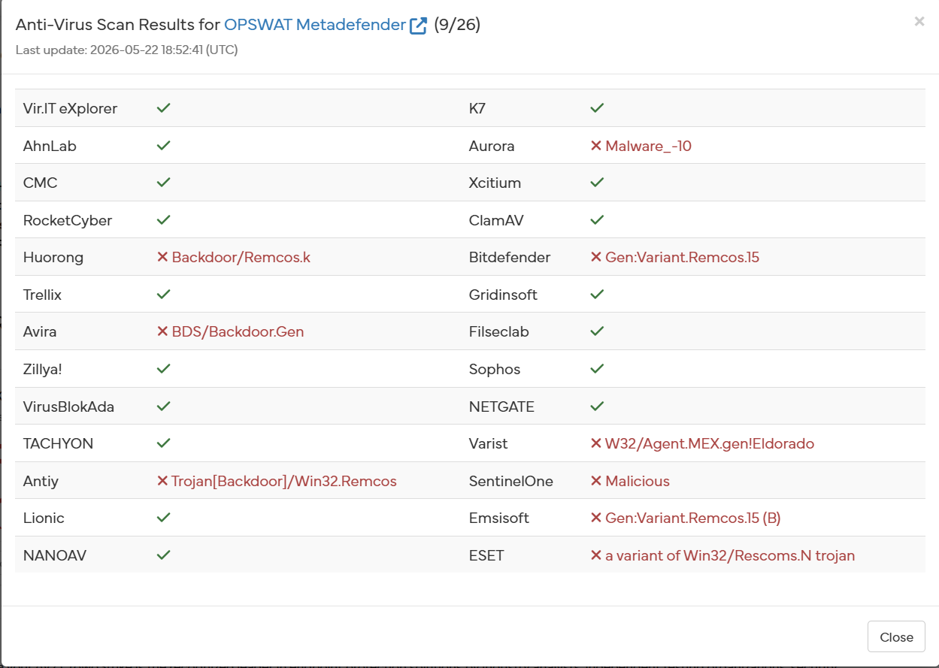

2.3 Exploiting Vulnerabilities Outshines Credential Theft
The 2026 DBIR analyzed over 31,000 security incidents and 22,000 confirmed breaches. The key findings are as follows:
• Vulnerability exploitation accounted for 31% of the initial intrusion vectors for the breaches, surpassing credential theft for the first time.
• AI-assisted attacks compressed the time from disclosing vulnerabilities to exploitation from several months to several hours.
• Generative AI has covered the entire attack chain: reconnaissance, initial intrusion, and malware development.

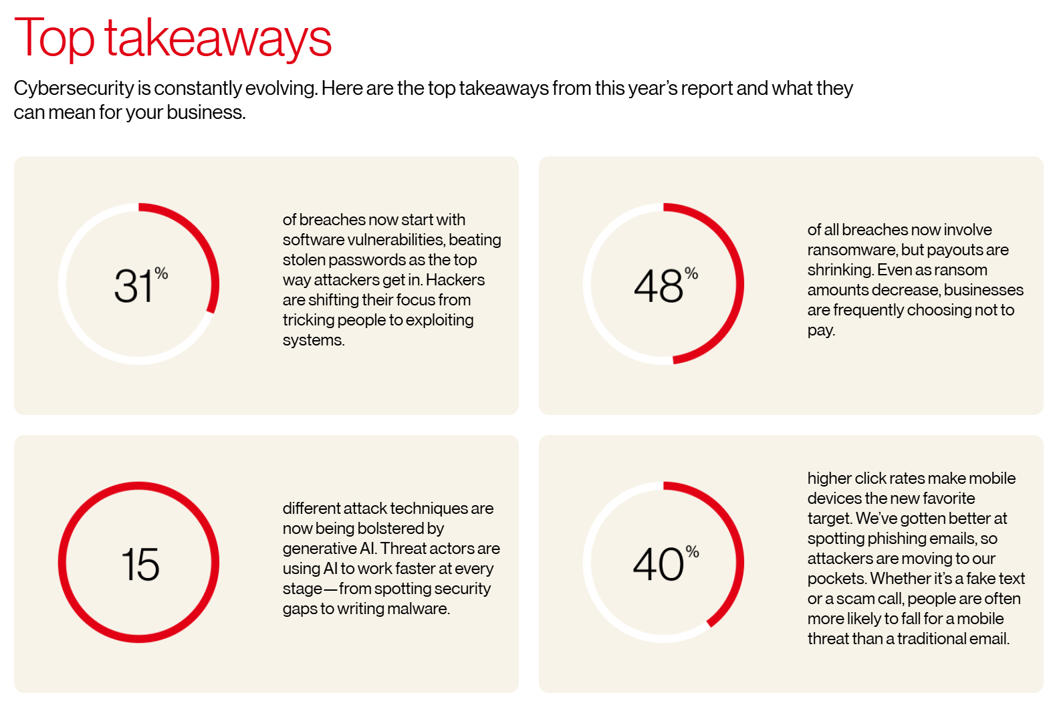
2.4 Supply Chain Risks Spread Widely
The number of third-party related leaks increased by 60% year-on-year, now accounting for 48% of all breach incidents. Several significant events in April all pointed to the same pattern: attackers no longer broke through from the front but quietly infiltrated through trusted third-party suppliers, OAuth connections, and CI/CD pipelines.
Meanwhile, AI crawler traffic grew at a rate of 21% per month, while human network traffic increased by only 0.3%. This gap indicates the arrival of the next wave of automated detection of attack surges.
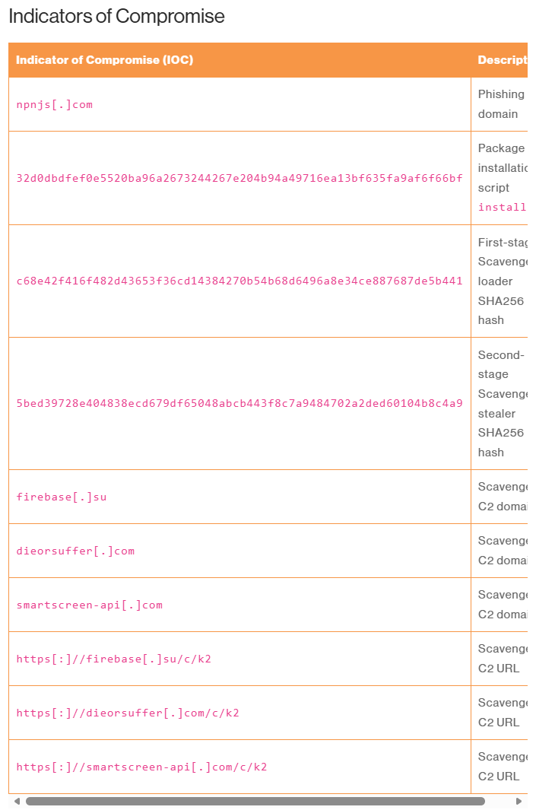
2.5 Shadow AI Becomes a New Channel for Internal Data Leakage
The report of the Verizon DBIR stated that the proportion of employees using unapproved AI tools ("shadow AI") increased threefold in one year, reaching 45%, becoming the third-largest method of internal data leakage. A Gartner survey showed that over 57% of employees use personal GenAI accounts to handle work affairs, and 33% admitted to inputting sensitive information into unapproved tools.

III. Advances in Defense Technologies
Quantum Security Migration Accelerates Gartner has listed post-quantum cryptography migration as one of the six major trends for 2026, recommending that organizations start planning for asset migration now before quantum threats become a reality to complete critical system protection.
AI Proxy Identity Management Challenges As Agentic AI is widely deployed in enterprises, traditional IAM strategies face new challenges: there are no mature standards for identity registration, credential management, and access control of AI proxies. Gartner suggests that security teams manage AI proxies as independent identity entities.
Behavior Detection Outperforms Signature Detection Cloudflare's response case to the Copy Fail vulnerability demonstrates the practical value of behavior detection: in the absence of signature updates and rule changes, its system automatically identified the exploitation pattern within minutes, without any manual intervention. This empirical evidence supports the industry trend of migrating to behavior-based baseline detection.
MicroVM Isolation Technology Gains Attention In response to the page cache attack primitive of Copy Fail, security researchers suggest migrating critical workloads to Firecracker, Cloud Hypervisor, or gVisor, etc., as microVM runtimes to maintain stronger isolation boundaries.
Invasion Vector Major Reversal: The "Credentials Theft" that has dominated for several years has fallen to the second position for the first time in 2026, while Vulnerability Exploitation (Vulnerability Exploitation) has become the largest initial invasion vector with a 31% share.
AI's Dimension Reduction Strike (Time-to-Exploit): The report jointly conducted with Anthropic for an AI threat-specific assessment. The data shows that attackers' speed in reverse engineering CVE patches using automated LLM red team intelligent agents has increased by 400%. The average time for vulnerabilities to go from public to full-network automated scanning, writing non-malicious Payload, and exploitation has been shortened to 3.8 hours. This means that the traditional "monthly/quarterly scanning and patching" mechanism is in a state of de facto failure.

IV. Conference and Academic Trends
Gartner Security Summit 2026 Core Trends (to be released in February) The six major trends have been widely confirmed by current events: Agentic AI cybersecurity supervision, post-quantum cryptography migration, AI proxy identity management, network resilience reconfiguration, regulatory compliance pressure, and the impact of GenAI on traditional security awareness training.
Noteworthy research directions
•Theori research team used the automated code analysis tool Xint Code to discover Copy Fail, demonstrating the boundary of the AI-assisted vulnerability discovery capability and triggering new thoughts on the "attack-defense competition pattern".
•Verizon 2026 DBIR and Anthropic jointly conducted a special study on the impact of AI in the security field. This is the first time that the official annual report clearly labels the AI threat assessment methodology.
•The automated vulnerability excavator of Xint Code: Theori research team demonstrated the complete process of its automated code analysis tool Xint Code discovering the "Copy Fail" vulnerability. The research shows that large models can not only be used for semantic analysis, but also, after combining symbolic execution and static taint analysis, AI can directly conduct large-scale automated deductions on the complex C language macros and memory boundaries of the Linux kernel.
•AI-assisted vulnerability discovery is causing the "attack-defense competition pattern" to tilt towards the attacker. Attackers can produce zero-day or pseudo-zero-day vulnerabilities at a very low cost in batches, while the blue team (the defense side) must fully shift to continuous detection engineering based on graph correlation (Continuous Detection Engineering).


V. Impact on the Company/Industry and Suggestions
outside threat | Internal exposure surface | level of risk | Technical Consequences
CVE-2026-31431 Linux Privilege Elevation | Production environment host, CI/CD Jenkins Runner, Kubernetes node image | high | If an attacker exploits a web vulnerability to gain access to the container, they can directly escape to the host machine and seize control of the entire cluster.
Supply Chain/Third-Party Intrusion | The company integrates various OAuth applications and third-party open-source components (NPM/PIP dependencies). | high | A cyberattack on our upstream supplier resulted in an indirect leak of our API keys or user data.
AI-assisted phishing + Remcos RAT | Office terminals and email accounts for finance, HR, and operations staff | high | Employees were targeted in phishing attacks, turning their devices into stepping stones for hackers to infiltrate the internal network and move laterally.
Shadow AI data breach | Employees independently use unauthorized public large-scale models for code debugging and business analysis. | medium | The company's core proprietary code or trade secrets were mistakenly uploaded to the public AI training dataset.
AI Web crawler detection | Open API endpoints and Web applications | medium

5.2 Ground-based Defense Roadmap (Priority Actions)
Immediate Execution (Within This Week)
Infrastructure stabilization: Immediately verify the kernel version of all Linux nodes in the production environment. For Kubernetes nodes that cannot be shut down and restarted, implement the blacklist policy for kernel modules and disable algif_aead.
CI/CD Image Hardening: Force the update of the base Docker images (such as Ubuntu, Alpine, etc.), ensuring that the build pipeline does not contain any underlying components with the "Copy Fail" vulnerability.
Short-term implementation (within this month)
Minimum privilege consolidation (SaaS/OAuth): Conduct a comprehensive audit of the company's existing service accounts (Service Accounts), third-party API tokens, and similar OAuth authorizations involved in Canvas events, and clean up idle and expired privileged accounts.
Identity Defense Upgrade: Given the evasive capabilities of kill-ware malware against traditional EDR, a strong authentication mechanism against phishing (such as FIDO2 / hardware security keys) must be introduced to prevent simple account passwords or SMS verification codes from being directly intercepted by phishing pages and RAT malware.
Mid-term implementation (within this quarter)
Advance software component analysis (SCA): Introduce automated SCA tools (such as Snyk, Trivy) into the CI/CD process, and conduct regular and real-time vulnerability risk scans for third-party open-source dependencies in production code.
Floor shadow AI governance policy: Deploy control strategies at the company gateway level to restrict core developers from submitting company-proprietary code to unauthorized external large models, and provide a compliant and controllable enterprise-level AI whitelist tool.

Reference
Data Sources
•Verizon 2026 Data Breach Investigations Report (May 2026)
•IBM X-Force Threat Intelligence Index 2026 (March 2026)
•CrowdStrike 2026 Global Threat Report
•Gartner Top Cybersecurity Trends 2026 (February 2026)
•Microsoft Security Blog: CVE-2026-31431 Analysis (May 2026)
•CERT-EU Advisory 2026-005 (April 30, 2026)
•Proofpoint 2026 AI and Human Risk Landscape Report
•Malwarebytes: Instructure/Canvas Breach Report (May 6, 2026)
•eSecurity Planet / SharkStriker Monthly Security Incident Tracking

Abbreviations
Abbreviation Full Name
DBIR Data Breach Investigations Report, Data Leakage Investigation Report
LPE Local Privilege Escalation, Local Privilege Upgrade
MFA Multi-Factor Authentication, Multi-Step Authentication
LMS Learning Management System, Learning Management System
IAM Identity and Access Management, Identity and Access Management
PoC Proof of Concept, Proof of Concept
RAT Remote Access Trojan, Remote Access Trojan
This report is for internal reference only and should not be disseminated externally. If you have any questions, please contact the security team.

